**PROPERTY MANAGEMENT SYSTEM**

**PROJECT REPORT**

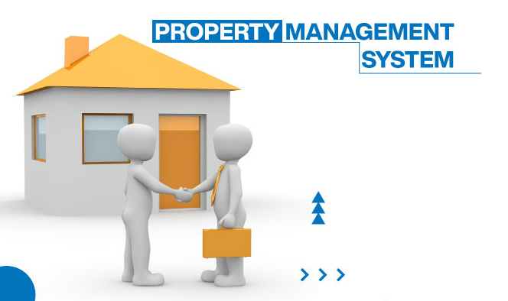

**Arun Raj (2012111)**

* ***Introduction:***

Property Management System is software that takes care of everything that a real estate company wants to do. Property Management System is developed for real estate companies. It is pretty strong and easy to use that makes quick booking and property handling process. The real estate property management system is desktop-based software that can be accessed from anywhere.

* ***Aims & Objectives:***
* To provide powerful logical user management for security
* To discuss project planning and the planning process
* To list all viewings for property
* To display matched property details easily and quickly by one click.
* To maintain client details line contact details, required property details, property type like flat, house and bungalows etc. Rents and dates.
* To maintain property details, booking of appointment for viewing property.
* ***Project Details:***
* Admin Profile:

Admin profile is a view which is assigned to an authorized user/staff having full access to the system. Admin can view the property details make changes if required, delete the property details. Check the client comments, view, and manage the client details. Any issue in the client’s details or in property details just reports to the admin.

* Client Profile:

The client profile is for those who want to buy, sell, or rent the property for their uses. Client profile contains Client id, name, address, contact details, etc. Clients can view the property. Clients can give comments regarding properties they visited.

* Property Details:

Property details hold the data about the property in property location, rent, owner, property type etc. It gives an idea about the property which helps the clients to choose the property.

* Add/Update/Delete Users:

Only the admin can add, update, and delete the client details and others user details. Admin has special permission to do so. User authentication according to his/her role. This module takes care of every profile in our system. No user is allowed to use our system without a profile. Every profile has to authenticate using system procedure. This would ensure the security of our system.

* ***ERD Diagram:***

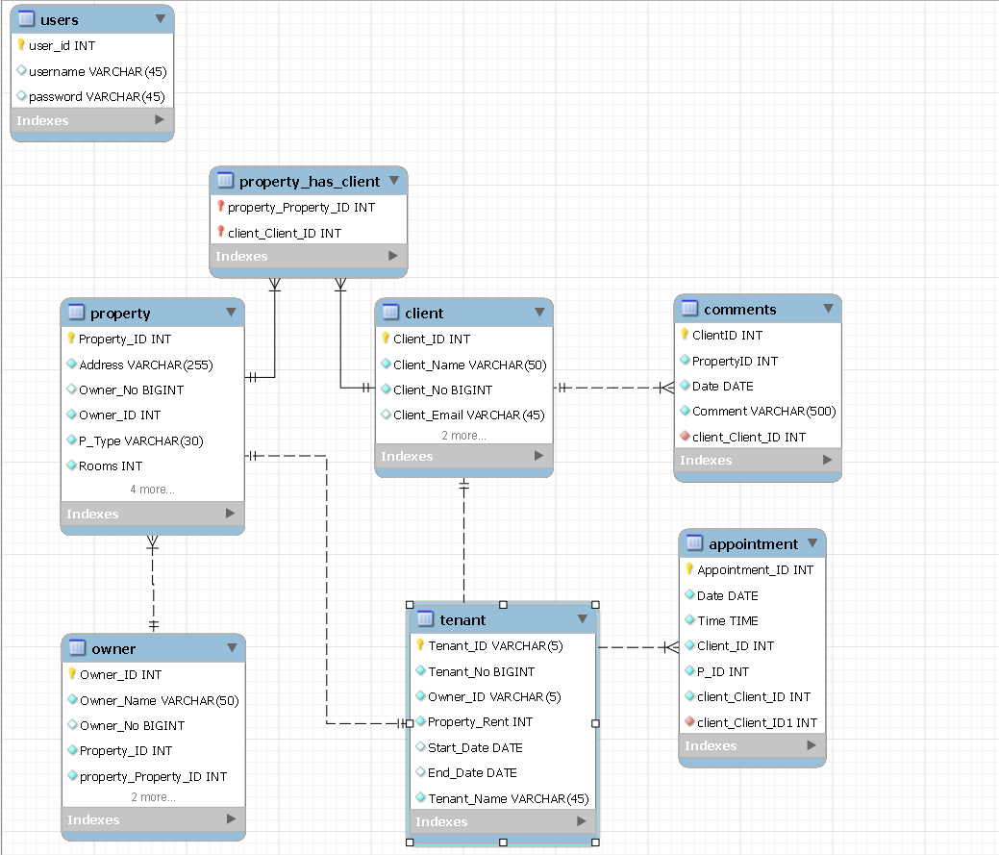

***Working***

As the application is started start panel is initiated which asks user to choose whether he/she is an admin or a client.

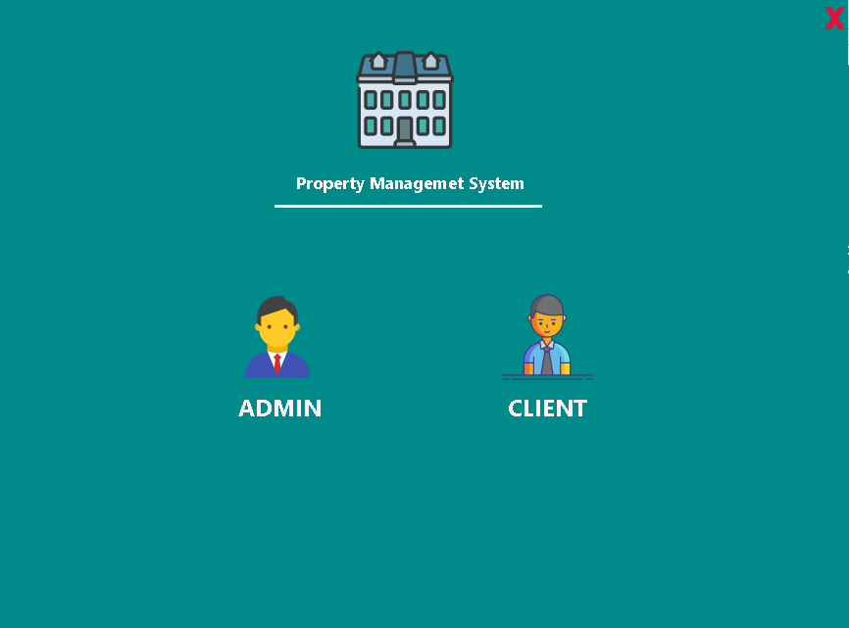

If the user chooses **Client** current window will dispose and client window will open that provides the client with all the property details.

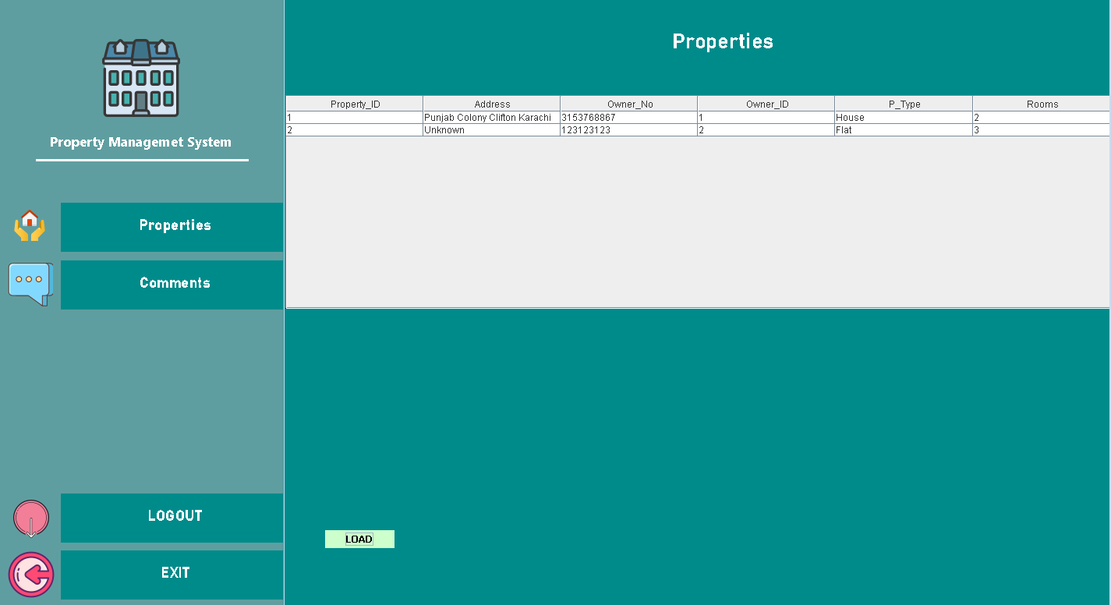

And can also view, insert and update and delete comments for desired property.

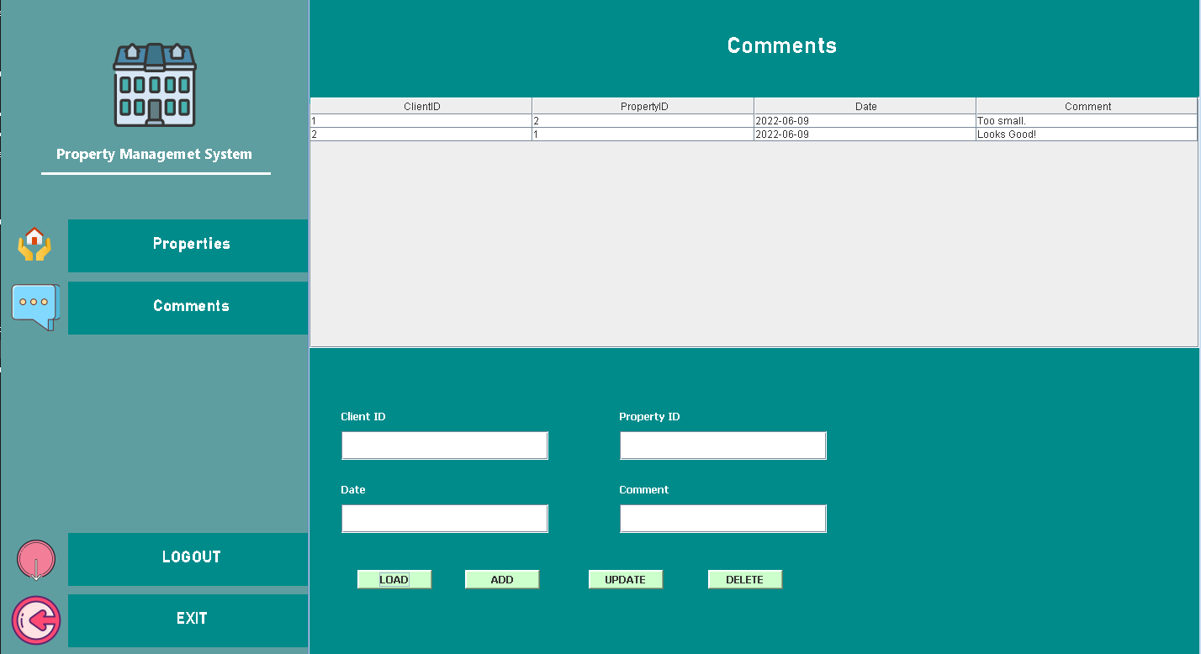

Coming back to start panel if the user chooses **Admin** he/she will be taken to the login page.

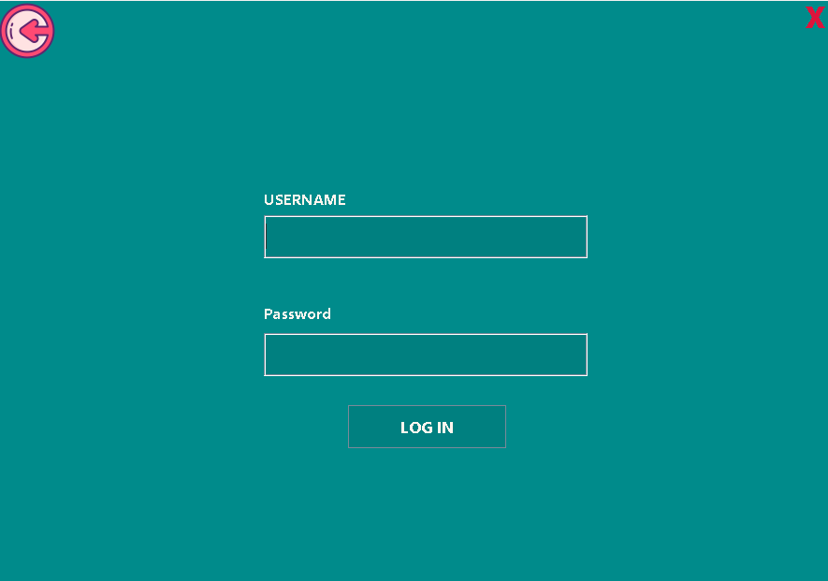

Every user will have his/her credentials.

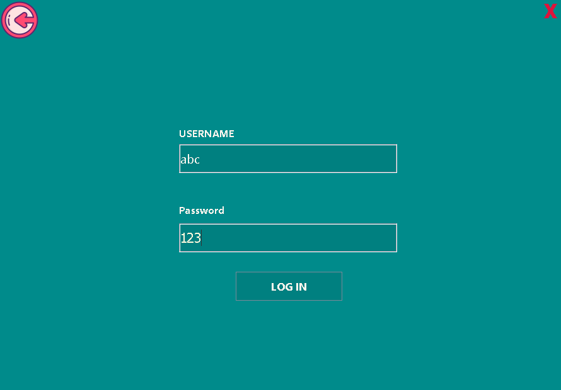

After logging in main window will be initiated that contains Property Details, Appointments, Tenant Details and Comments.

**Property Details**

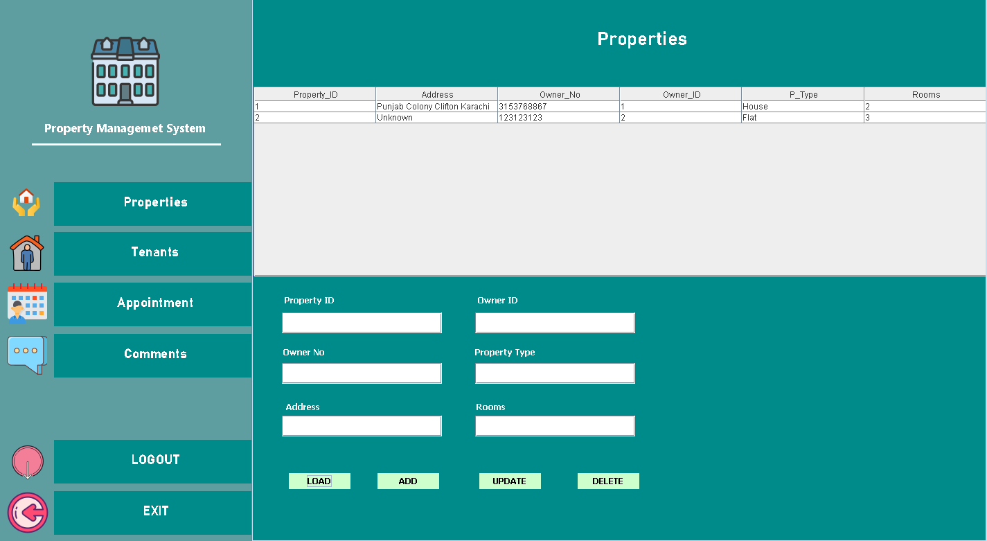

**Tenants**

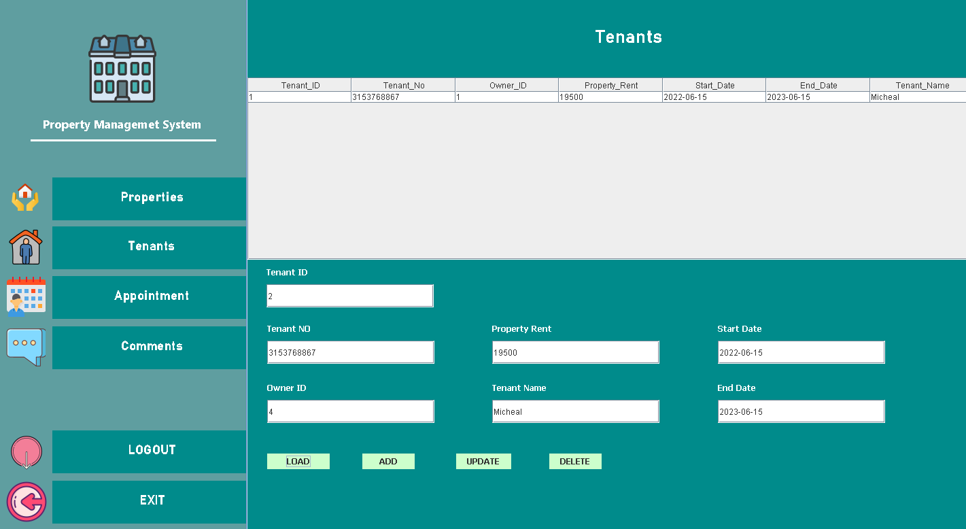

Appointment

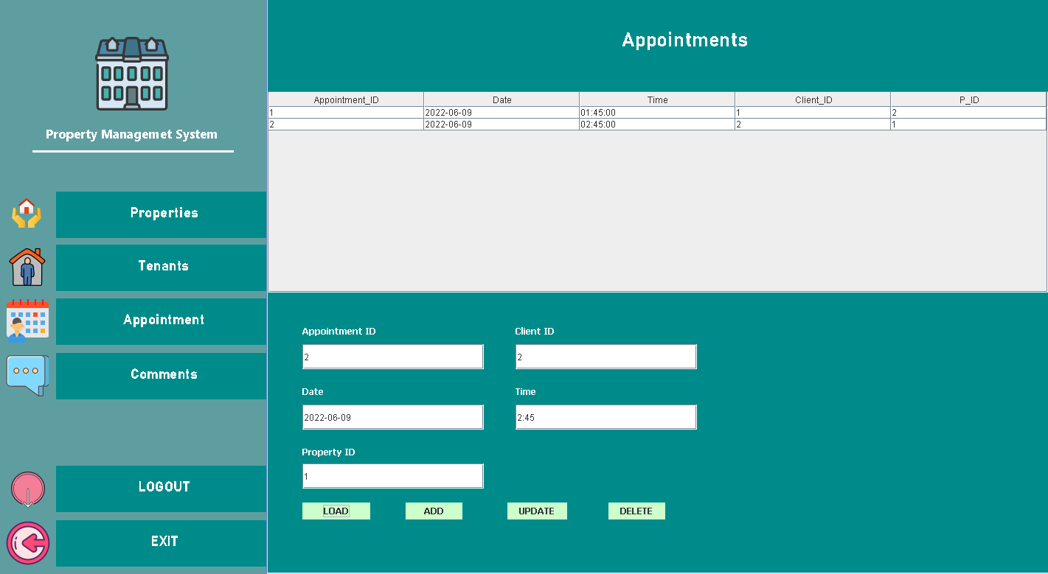

Comments

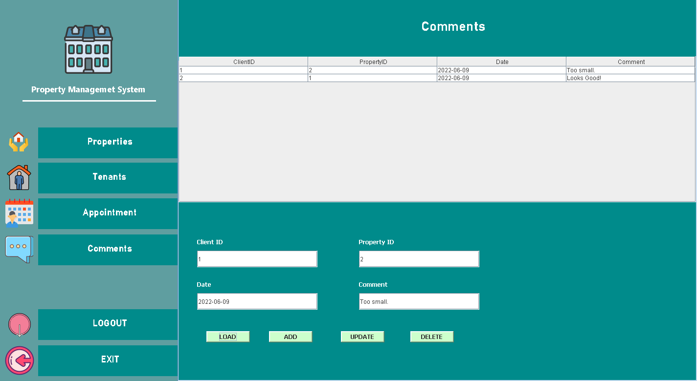

The **LOGOUT** button takes back to start panel where user can choose from **Admin** or **Client**.

The **EXIT** button closes the application.

THE END